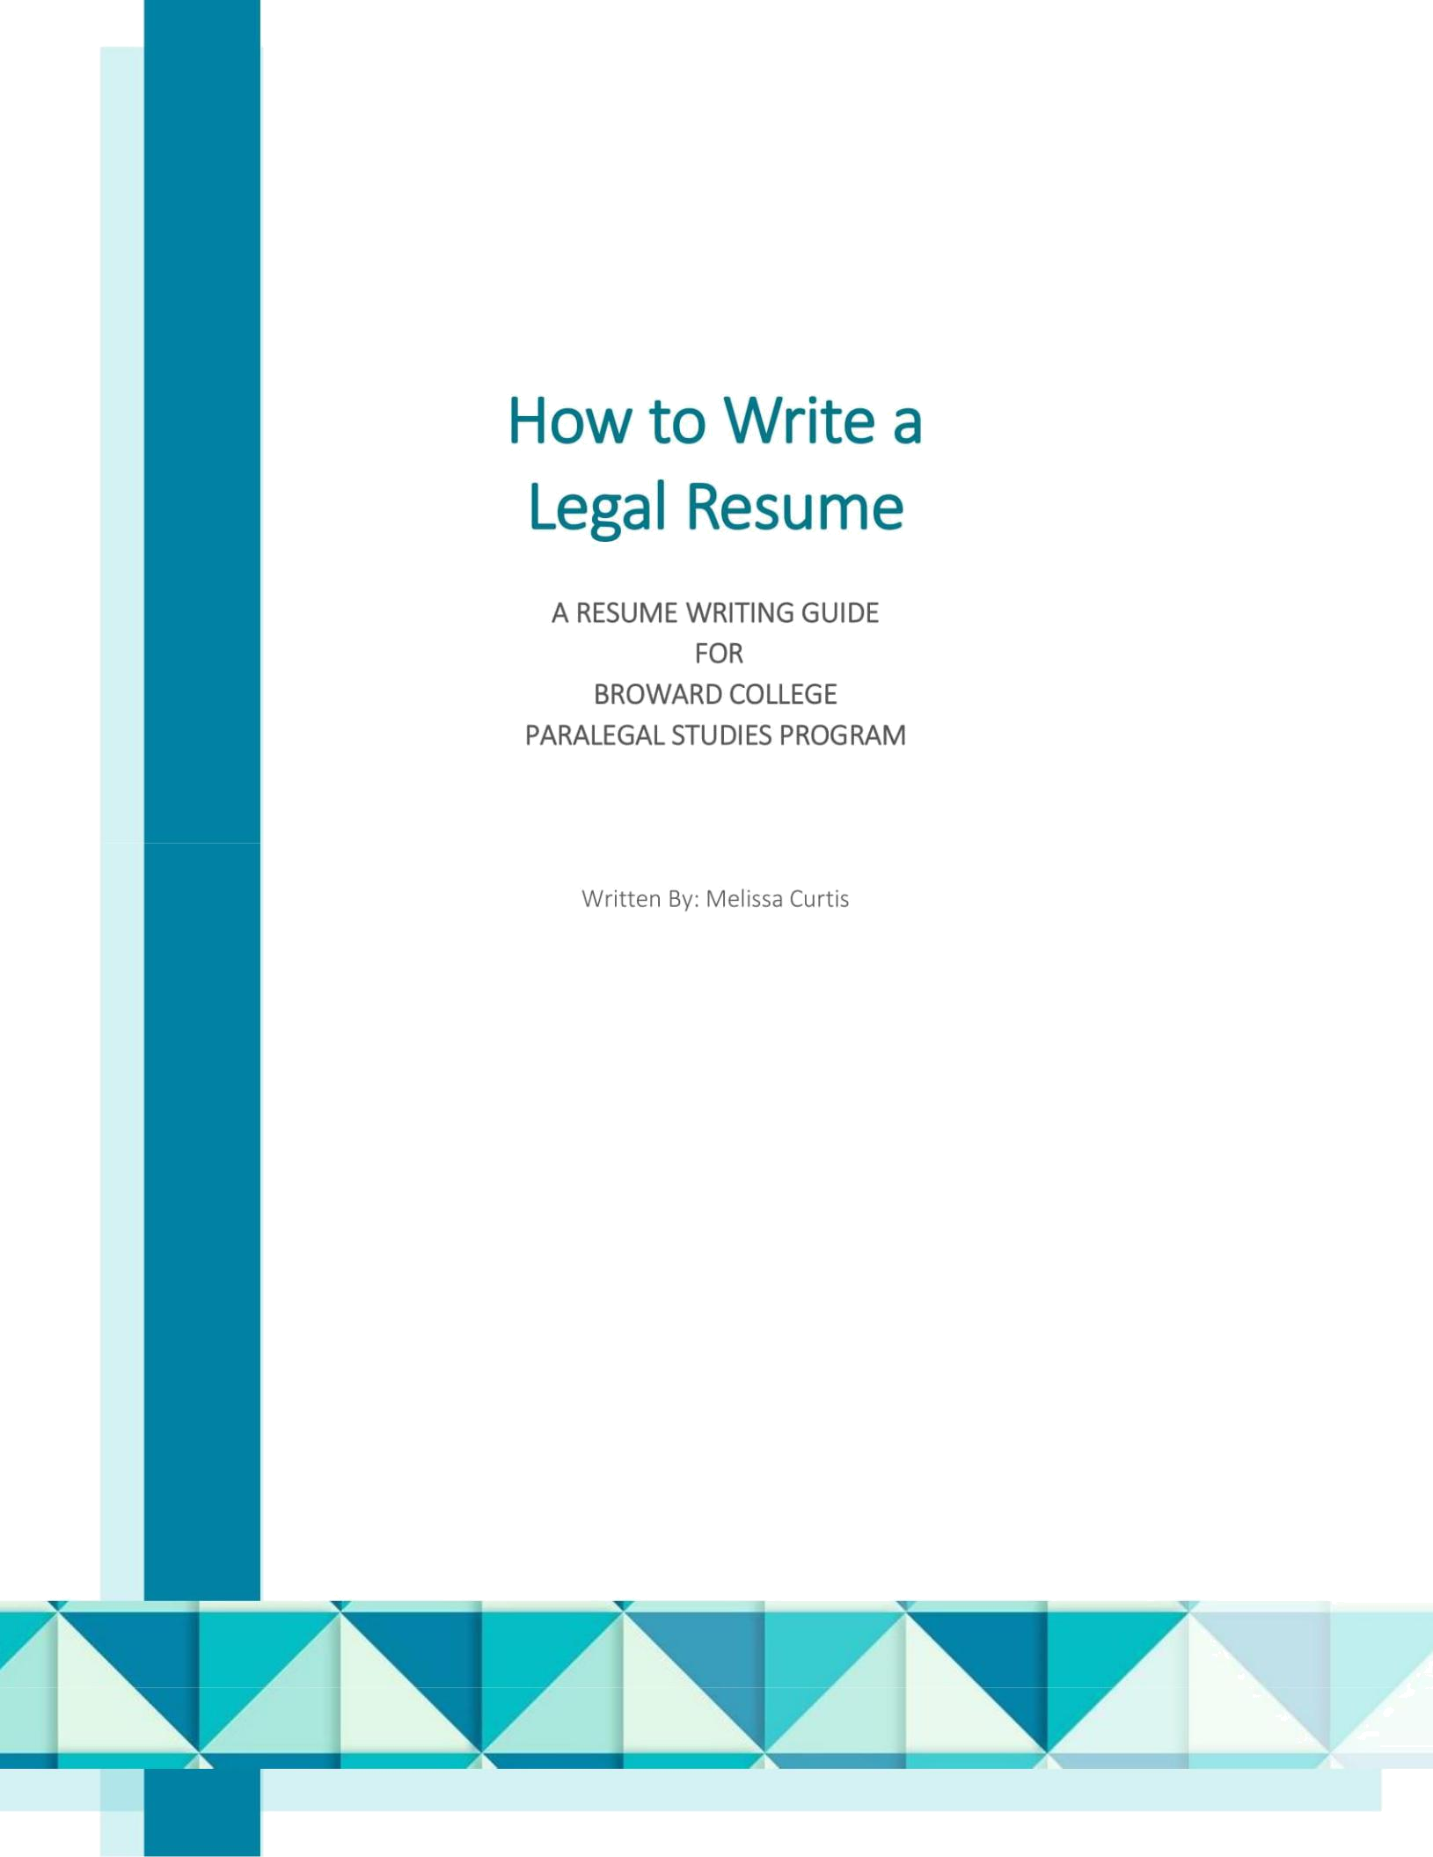

Introduction

Your resume is a career narrative, it is your chance to tell a story about what you have achieved in the past and your goals for the future. It should reflect who you are as a candidate, including your skills, experience and potential. The ultimate purpose of your resume is to get you a job interview. However, a great resume can help you become a front runner in the interviewer’s mind before you even meet.

While many candidates have excellent skills and considerable professional experience, when it comes to writing their resume, they are stumped by the task of choosing a structure, understanding what should be included or left out, and properly detailing their experience. The aim of this guide is to help you create a resume that will not only land you a job interview, but also help you land a job offer.

2
Table of Contents

INTRODUCTION 2

1. CONTENTS 3

PERSONAL DETAILS 4

THE OBJECTIVE 4

WORK EXPERIENCE AND DESCRIBING JOB DUTIES 5

CORE COMPETENCIES 6

VOLUNTEER WORK 6

EDUCATION 7

MEMBERSHIPS AND AFFILIATIONS 7

SKILLS 7

REFERENCES 8

TAILORING YOUR RESUME 8

ETHICAL CONSIDERATIONS 8

2: STRUCTURE 9

WHY LAYOUT MATTERS 9

CHRONOLOGICAL LAYOUT 9

FUNCTIONAL LAYOUT 9

CHRONOLOGICAL LAYOUT EXAMPLE 10

FUNCTIONAL LAYOUT EXAMPLE 12

WHICH RESUME TYPE SHOULD I USE? 13

3
1. Content
Before you dive into writing your resume take some time to gather all the information you are going to need to faithfully detail your employment history and job duties. Start by collecting the company name, dates of employment and job title for each position. Then, consider who can act as a reference for you from each job. Gather your educational history including degrees acquired, dates of attendance, any honors or awards, and certifications. Finally, begin jotting down any skills you have that may be relevant to your search, such as software programs used at different jobs, language skills or any other specialized training.

Personal Details
Regardless of how you choose to structure the rest of your resume, should begin with a header consisting of your full name, location and contact information.


Calamity Jane

Deadwood, South Dakota | (000) 123-4567 | j.calam@mailcoach.com

As job boards have moved online, it is advisable not to include all of your personal details on your resume. A zip code or city will suffice, along with your phone number and email. Employers only need to be able to get in contact with you and understand your general location. You should also avoid expressly including information such as race, gender, age, marital status, physical appearance, health information or any other such personal details.

The Objective
Because most resume templates include a space for an objective, many candidates feel they need to include one at the beginning of their resume. However, most objectives are generic and fail to increase your appeal to hiring professionals. If you choose to include one, avoid vague phrases, such as those in the example below, that say little to nothing about you as a candidate or your skill set.

‘Seeking legal position that best utilizes my skills in a dynamic corporation or firm where I can grow and contribute to a team.’

Remember that space on your resume is limited so you must use it deliberately, and a lackluster objective does nothing to differentiate you from the next candidate. Only include an objective if it shows off your skills, and gives the person reviewing your resume an idea of how you would fit into their team. In the example below, note the underlined words specifically highlight the skills, experience and job search goal of the applicant.

‘Bilingual Corporate Paralegal with over 5 years experience supporting the General Counsel of a multinational telecommunications company, seeks new challenge in large law firm environment.’

Only include an objective if you have a specific job goal in mind. Do not include one if you are more interested in seeing what types of positions are available. It is better to have no objective than something vague or dull; you do not want a hiring committee to associate you with either of those adjectives!

4
Work Experience and Describing Job Duties
Each position should be listed in reverse chronological order, include the name of the company, dates of employment and position title. Your resume should highlight the skills and daily tasks of each position, as well as your major achievements. Each position should contain between 5-8 bullet points, with each bullet point containing 1-2 sentences detailing job duties along with examples.

Formatting a Strong Bullet Point

Action Verb + Description of Activity + Result/Scope + Example

‘Drafting internal compliance policies and contracts for over 150 employees such as NDA’s, Employment

Agreements and HR Documentation’

Always lead with a strong action verb either in the ‘-ing’ form, or in the past tense, commonly ‘-ed’ form. Either is fine, but make sure you are consistent!

 |  | Sample Action Verbs
Delegating | Maintaining | Budgeting |  | Scheduling
Solving | Implementing | Improving |  | Researching
Managing | Creating | Generating |  | Distributing
Drafting | Editing | Filing |  | Investigating
Liaising | Overseeing | Arranging |  | Summarizing
Advising | Developing | Analyzing |  | Assisting
Preparing | Assessing | Organizing |  | Docketing

Similar job duties should be grouped together under each bullet point such as document drafting, technology skills, large projects or clerical duties.


Experience:

Tumbleweed Attorneys | 2015 – 2018

Paralegal

- Drafting legal documents including trusts, wills, powers of attorney, leases and correspondence.

- Preparing for trials or hearings, including compiling medical records, preparing witnesses including experts, compiling exhibit binders and trial notebooks.

- E-filing and e-service with the state and federal courts through PACER or EM/ECF.

- Scanning, copying, filing, transcribing and all other clerical duties as needed.

Major online job boards including Indeed, CareerBuilder and ZipRecruiter all have search functions, whereby employers can locate candidates with specific skills using Key Terms. To give yourself the greatest chance of appearing in searches, make sure you are including Key Terms in your description as well. These can be: any specific legal skill such as ‘E-filing;’ an area of practice such as ‘Mergers and Acquisitions’, ‘Insurance Defense’ or ‘Corporate Governance’; or general technology and language skills like ‘PACER’ or ‘Spanish’.

Return On Investment (ROI)

Also try to include at least one Return On Investment (ROI) statement for each position. An ROI statement should highlight an achievement or value added while you worked in each role. Examples of ROI’s include saving the company money, finishing a project at or before deadline, creating a new organizational system, receiving an award or consistently hitting goals set by management. Try to quantify your contributions using dollar amounts, percentages, number of documents, and other similar information, to give your achievements more credibility.

5
‘Supporting 3 senior associates with a caseload of 50+ complex litigation matters, and

consistently exceeding high billable hours requirements.’

There are myriad forms that an ROI can take, so take your time to carefully think over what you are proud to have achieved in each role and include it on your resume.

Core Competencies
Core competencies may be thought of as themes. Examples of core competencies may include specific practice areas, skills or areas of expertise and should only be included in a Functional resume layout. (The two types of layouts are outlined in Section 2: Structure). You should describe your skills and projects under the umbrella of core competencies.


Core Competencies

Contracts Management

- Updating and maintaining various contract tracking databases.

- Filling contracts from forms and developing new contract forms under attorney guidance.

- Monitoring and ensuring completion of contract events including renewals, terminations and deliverable dates.

- Assisting with due diligence in mergers and acquisitions documents.

- Monitor and ensure compliance with state and federal regulations including corporate and SEC filings.

Software and Language Skills

- Aderant (ATO)

- Time Matters

- PC Law

- Time Slips

- PACER

- Florida E-Portal

- Spanish, English and Portuguese

Volunteer Work
Volunteer work needs a separate subheading briefly listing the organization, role, outstanding achievements and dates of service. No more than 2 bullet points outlining your role in each volunteer position are needed.


Volunteer Work:
Guardian Ad Litem – Miami, FL |  | January 2015 – Present
Volunteer

- Advocating for the needs and interests of children in the foster care system through weekly visits to check on the child’s needs and wellbeing, attending hearings and writing recommendations for the courts.

Only include long running volunteer positions, do not clog this section with individual fundraisers like 5k’s or bake sales.

6
Education
Next list your education in reverse chronological order. Include completed certifications with your most recent degree first. List the awarding institution, the year you graduated, and your major and any minors. Also include any honors or inclusion on the dean’s list. Only list your GPA if it is at least a 3.5 or above.

Education:
Broward College |  | 2005
Paralegal Studies Certificate - ABA Approved
University of Miami |  | 1992

Bachelor of Business Administration, Minor in Political Science

If you have an associate’s degree or above, do not include your high school diploma.

Memberships and Affiliations
Provide brief details of memberships and affiliations including paralegal certifications, notary commissions, board memberships and the like in this section.


 | Memberships and Affiliations:
 | • | Florida Notary |  | (Commission expires 2021)
 | • | Florida Registered Paralegal |  | 2018

Skills
The final section details your relevant skills including language abilities and any technology or software skills. All of your skills must be concrete and measurable. Do not include vague terms such as ‘team player’, ‘fast learner’ or ‘organized.’ These are soft skills that an interviewer will evaluate during the interview or on the job.

Skills:

- Software: Aderant (ATO), Black Knight (LPS), Acuity, Dragon Speak and Microsoft Office Suite

- Languages: English and Spanish

7
References
References may be from previous employers, teachers (if you are seeking your first job) or a volunteer agency’s management. Never assume someone will act as a referee. Always obtain consent before listing anyone as a referee. As a courtesy do not include their information on your resume. Instead type out a separate document with the name, title, phone number and email of each person providing a reference. Only give this document to a potential employer once you are in serious consideration for the position.


Johnny Appleseed - References:

Oprah Winfrey

Supervisor, the Oprah Winfrey Show

(305) 111-1111

Ellen Degeneres

Supervisor, the Ellen Degeneres Show

(305) 111-1112

Judge Judy

Manager, the Judge Judy Show

(305) 111-1113

Tailoring Your Resume
Uniquely tailor your resume to highlight that your skills meet a hiring company’s requirements. This makes it easier for potential employer to understand how you fit their needs. Do not re-write your resume for each and every position, instead save time by creating a Master Resume. A Master Resume is a complete compilation of all your skills and experience into one master document with every job, skill, certification and degree properly detailed according to the guidelines listed above. The, to tailor your resume to a specific job posting, create a new resume by picking out the sections that apply to the specific job, skill or achievement, from the Master Resume.

Note: During the interview process you should bring copies of both your Master Resume and your Tailored Resume in case you need to refer to some experience or skill set you have not included in the tailored version. An interviewer may be interested in experience that you had not anticipated, and it is always best to be prepared.

Ethical Considerations
Finally, you should always be truthful throughout the recruiting process. Embellishing your skill set, falsifying your employment history and otherwise including incorrect or misleading information in your resume can significantly damage your reputation, and even cause a job offer to be rescinded.

8

2: Structure

Why Layout Matters
Along with content, structure dictates the first thing potential employers will learn about you and therefore, what their first impression will be. Research has shown it takes seven additional good interactions to make up for a first bad impression, so it is critical not to disadvantage yourself from the beginning.

There are two main resume structures to choose from when applying for jobs within the legal field: the Chronological layout and the Functional layout. Choose the resume style that best suits the type of job you seek, your unique skill set, and experience. Of course, these are general guidelines, and, in most cases, you will need to make individual tweaks in order to best fit your search.

Note: Many resume writing guides still stress the importance of a keeping your resume to one page in length, but it is far more important to correctly detail your skills and experience. Employing tiny margins and ridiculous formatting for the sake of keeping your resume to one page will ultimately be to your detriment. It is more important to ensure all relevant experience is included.

Chronological Layout
The most common layout is based around experience and is arranged in reverse chronological order which lists the most recent positions first.

A Chronological layout should include the following factors:

- A header with the candidate name, phone number, email and location.

- A section for Work Experience with each position listed in reverse chronological order.

- An Education section, listing each degree or certification obtained in reverse chronological order.

- A Memberships and Affiliations section listing any pertinent organizations or qualifications separate from education and experience.

- A Skills section outlining any technology, language or other similar skills.

Functional Layout
A Functional layout is a skills-based layout and allows for much greater variation in style than a Chronological resume, however there is also a greater possibility for making mistakes. The most important consideration for a skills-based layout is whether your resume has good flow. Flow occurs when there is a clear and logical progression of ideas moving down the page and a resume with good flow is easy to read and understand.

For English speakers, the eye naturally wants to travel from left to right and down the page. Format your resume to accommodate this inclination by laying information out in horizontal sections moving down the page.

A Functional layout should include the following factors:

- A header with the candidate name, phone number, email and location.

- A Core Competencies section grouped by areas of expertise.

- A Skills section with your technology, certification and language skills.

- An Experience section briefly outlining each position, area of practice and an ROI.

- An Education section, listing each degree or certification obtained in reverse chronological order.

9
Chronological Layout Example
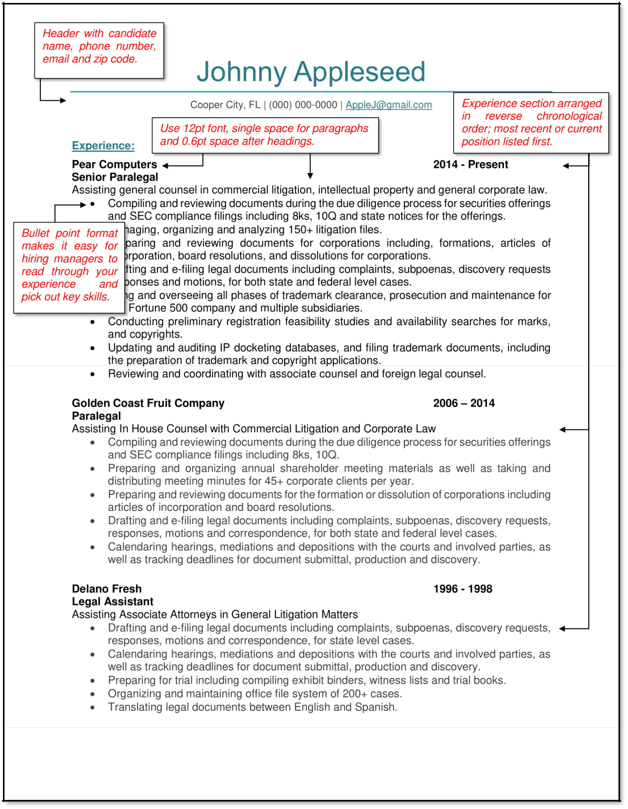

10
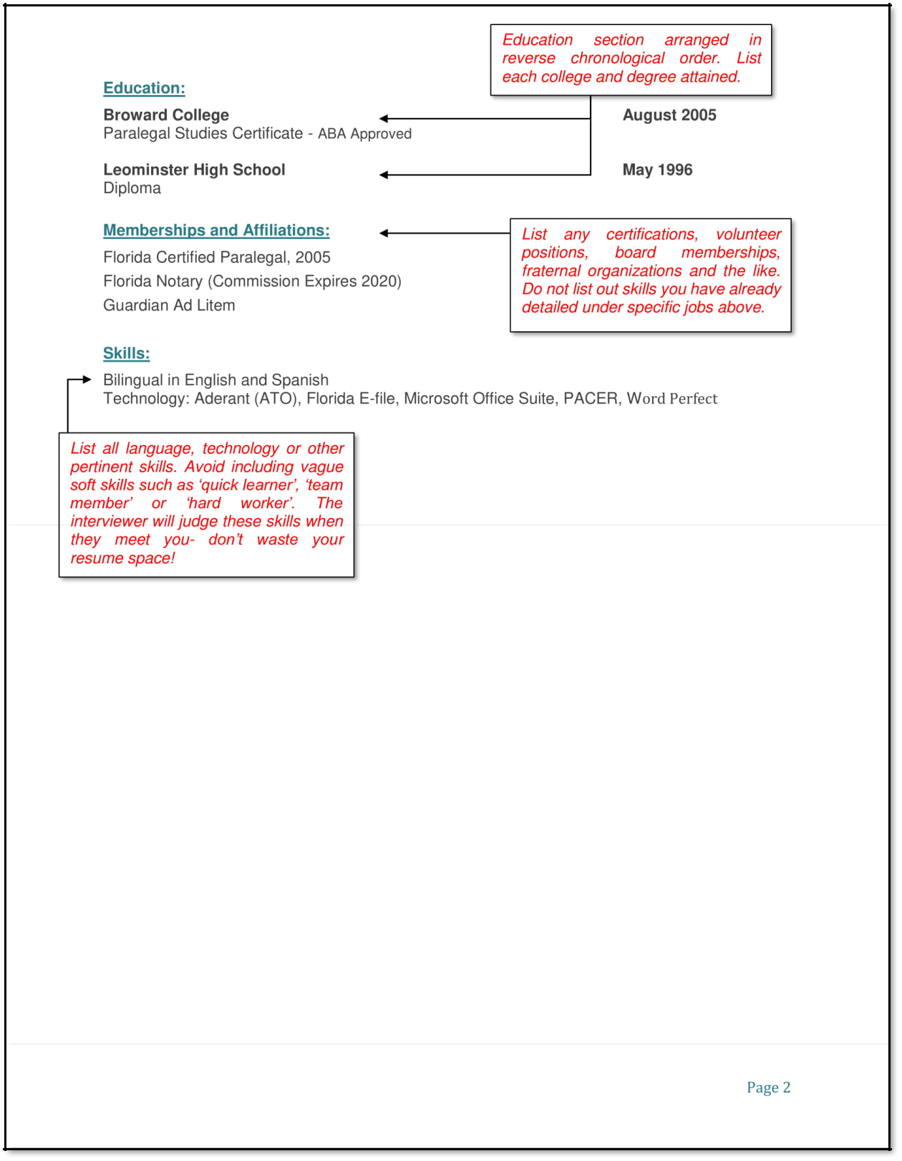

11
Functional Layout Example
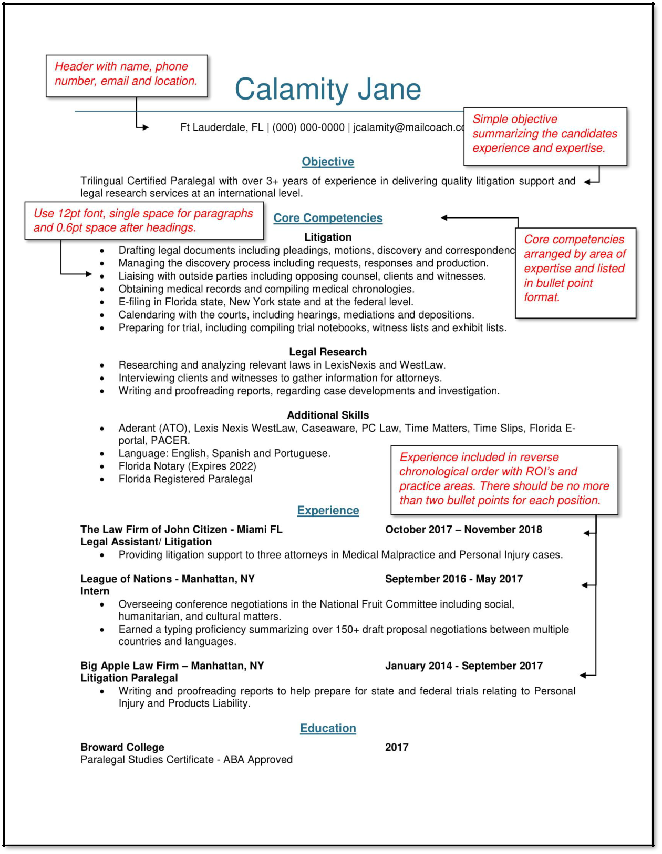

12
Which resume type should I use?
Most candidates should use a Chronological layout, even if you have gaps in your resume or are starting in a new field. Employers will want to know your work history no matter how you initially present yourself. This is particularly pertinent to the legal industry, and even more so for litigation positions, because of conflicts of interest considerations.

Chronological Layout:

Advantages:

- Familiar format for hiring professionals and therefore easily understandable.

- Applicant Tracking Systems (ATS) can easily parse this format.

- Emphasizes stable work history and linear career development.

Disadvantages:

- While this format is familiar for recruiters and interviewers, it won’t help you stand out from the crowd.

- Employment gaps or a lack of experience are more noticeable.

Functional Layout:

Advantages:

- More room to be creative and stand out from other applicants.

- Could help minimize work or experience gaps.

Disadvantages:

- A much higher risk of looking disorganized or being poorly executed.

- Does not show how or where you gained certain skills.

- More difficulty being parsed through ATS.

Clearly, there are more risks involved in using a Functional layout and the majority of job seekers should use a Chronological layout. A Functional resume is best used when you are making a career switch, just entering the workforce, or have been working on a freelance or project base.

13

